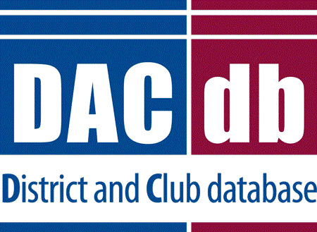 | DACdb Grants Module Club Process
GRANT FINAL REPORT

COMPLETING THE FINAL REPORT

- Some Districts require an Interim Report. If your District requires one follow the same procedure.
- Once you have completed the project you must complete an on-line Final Report
- Go to the District Database
- Click on the My Club

- Click on the Club Grants Icon

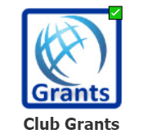

- Click on Club Grants View on left side menu

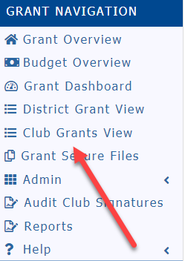

- Click on the edit button (pencil) of the grant you wish to complete.

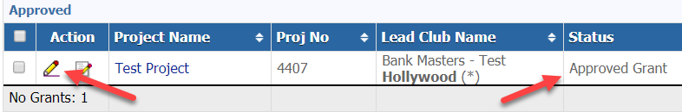

- The grant status must say “Approved Grant” otherwise the Final Report will not appear
- First, click on the budget tab and make sure you replace the information with actual funds and expenses. You must itemize each receipt and copies of the receipts must be uploaded in the documents.

- Scan photos of the project and rotary involvement, all receipts and copies of any checks you may have disbursed and save them as “jpg” or “png” files and upload them to the Documents tab.

- Click on the Final Report Tab

- Some Districts will only use the Final Report
- Complete items 2, 4, 5 and 6. Items 1 and 3 are filled in automatically. You cannot leave any of this information blank.
- Your photos and receipts will automatically appear under the photo and receipt section if you saved them under documents as a “jpg” or “png” file.
- The Final Report must be completed by one of the two individuals in the club who prepared the grant request and can only be signed by the Club Signees.
- When you are finished with the Final Report, click on the “Save Final Report” to save your work.

- The two individuals designated as club signees will need to sign the “Final Report”
- After you save the final report the club signees are ready to sign it. The first Club Signer will click on the edit button, click on Final Report and click on “Club – Collect Final Signatures”

- A new button, “Club: Sign Final Report” will appear on the top right. Signer will click on the box.

A new box will appear, click on sign grant
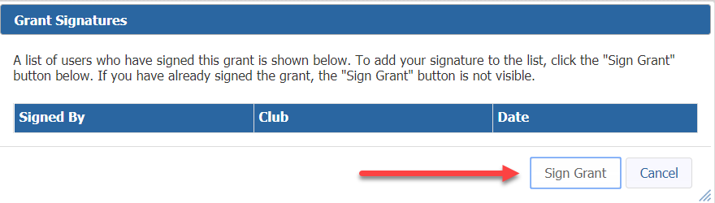

- The second signer of the Final Report will now go to the database and click on the pencil to edit the grant. Click on the Final Report tab and they will click on the “Club: Sign Final Report” button.

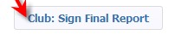
- The sign grant box will pop up. You will see the signature of the first signee - click on “Sign Grant”

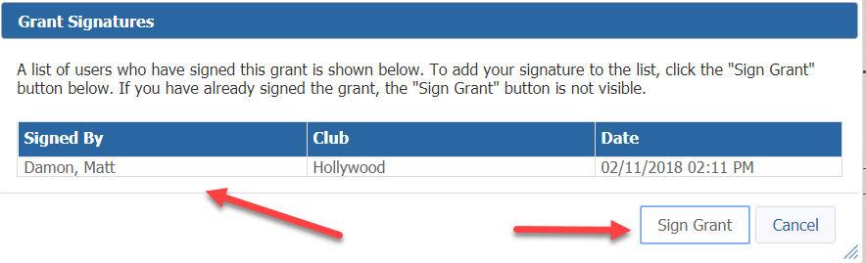

- The second signer will now click on “Submit Final Report”

- The status of your grant will now be changed to “Submitted final report for District Approval”

- Depending on the District the Final Report will be reviewed, audited and/or approved.

